TABLE OF CONTENTS
LIST OF TABLES iii
LIST OF FIGURES iv
LIST OF ABBREVIATIONS v
CHAPTER 1 1
INTRODUCTION 1
1.1 Background 1
1.2 Statement of the Problem

This problem statement is grounded in the recent Nepal-focused study by Bhandari, Pandeya, Jha, and Jha (2024), which explores graph neural networks for weather prediction in data-scarce environments. That paper is used in this proposal as the recent reference foundation and literature benchmark. The present study extends that direction to a 320-station STGCN forecasting setup in which station connectivity is defined by historical weather-signal similarity rather than physical distance alone.

3
1.3 Research Objectives 4
1.4 Significance of the Study 5
CHAPTER 2 7
LITERATURE REVIEW 7
2.1 Graph Convolutional Networks 7
2.2 Spatio-Temporal Graph Convolutional Networks 8
2.3 Attention-Based and Adaptive Graph Methods 8
2.4 Weather Forecasting in Complex Terrain 9
2.5 Positioning of This Proposal 10
CHAPTER 3 12
METHODOLOGY 12
3.1 Process Method 13
3.1.1 Data Collection 13
3.1.2 Pre-Processing 15
3.1.3 Data Splitting 17
3.1.4 Model Training 18
3.1.5 Classification 20
3.2 Validation and Verification 21
3.3 Evaluation Metrics 21
CHAPTER 4 23
EXPECTED OUTCOMES 23
4.1 Scientific and Methodological Contributions 23
4.2 Forecasting Performance Expectations 24
4.3 Application Relevance and Future Integration 24
CHAPTER 5 26
THESIS SCHEDULE 26
REFERENCES

Bhandari, H. C., Pandeya, Y. R., Jha, K., & Jha, S. (2024). Recent advances in electrical engineering: exploring graph neural networks for weather prediction in data-scarce environments. Environmental Research Communications, 6, 105010. https://doi.org/10.1088/2515-7620/ad8108

27

LIST OF TABLES
Table 1: Comparison of graph-based spatio-temporal forecasting approaches relevant to this study 10
Table 2: Input feature variables and their physical categories used in the STGCN model 14
Table 3: Proposed STGCN model architecture and hyperparameter configuration 19
Table 4: Evaluation metrics for model performance assessment 22
Table 5: Proposed thesis research schedule 26

LIST OF FIGURES
Figure 1:Conceptual diagram of distance-based versus correlation-based graph construction in complex terrain 3
Figure 2: Schematic of the Overall Research Methodology Workflow 12
Figure 3: Spatial distribution of the 320 weather stations across Nepal's physiographic zones 13
Figure 4: Correlation-Adaptive Weather Graph construction and sparsification pipeline 16
Figure 5: Temporal sliding window logic and STGCN input tensor construction 17
Figure 6: Architectural Overview of the Proposed Three-Block STGCN Model 18

LIST OF ABBREVIATIONS
GCN Graph Convolutional Network
GNN Graph Neural Network
STGCN Spatio-Temporal Graph Convolutional Network
ASTGCN Attention-Based Spatio-Temporal Graph Convolutional Network
LSTM Long Short-Term Memory
MSE Mean Squared Error
MAE Mean Absolute Error
RMSE Root Mean Squared Error
NASA POWER NASA Prediction of Worldwide Energy Resources
APHRODITE Asian Precipitation – Highly-Resolved Observational Data Integration Towards Evaluation
T2M_MIN Minimum Temperature at 2 metres
RH2M Relative Humidity at 2 metres
PRECTOTCORR Corrected Total Precipitation
HPC High-Performance Computing
GPU Graphics Processing Uni

CHAPTER 1

INTRODUCTION

1.1 Background
Accurate short-range weather forecasting is foundational infrastructure for mountainous developing nations. In Nepal, where agriculture supports the majority of rural livelihoods and natural hazard exposure is high, the quality of weather predictions directly affects planting decisions, irrigation timing, flood preparedness, and market logistics. The challenge is not merely computational it is spatial.

In low-relief regions, most spatial forecasting methods rest on a spatial smoothness assumption: nearby stations experience broadly similar atmospheric conditions, and geographic proximity is a reliable proxy for meteorological affinity. When this holds, distance-based graph construction is not only acceptable but effective.

Nepal systematically violates this assumption. The country spans nearly 9,000 metres of elevation within roughly 200 kilometres of horizontal distance. A single mountain ridge can separate two stations that appear adjacent on a map but experience entirely different weather regimes. Windward slopes receive orographic precipitation from monsoonal flows; leeward slopes sit in rain shadows. Valley floors collect cold air through nocturnal drainage, producing temperature inversions. South-facing slopes receive substantially more solar radiation than north-facing slopes at equivalent elevations, generating sharp temperature differentials between topographically adjacent stations.

These are not edge cases or rare exceptions. They represent the dominant character of spatial weather variability across Nepal's middle hills and high-altitude zones, and they imply that distance-based graph construction the most common approach in spatio-temporal graph neural network literature is a structurally inappropriate choice for this setting [1], [2].

Graph Neural Networks (GNNs) have emerged as powerful tools for structured prediction over relational networks [3], [1]. Within the GNN family, Spatio-Temporal Graph Convolutional Networks (STGCNs) have demonstrated strong performance in traffic forecasting, where the graph is naturally defined by road topology [1]. The STGCN architecture captures spatial dependencies across connected nodes and temporal dependencies along the time axis through a sandwich-structured ST-Conv block, making it well-suited for multi-step prediction over graph-structured time series [1]. Recent work has extended the range of GNN-based approaches to global weather forecasting [4], probabilistic prediction [5], flood modelling [6], and fine-scale regional emulation [7], demonstrating both the potential and the open questions that remain for complex-terrain applications.

The application of STGCN to weather station networks over complex terrain requires answering a question that the traffic domain avoids: how should the graph be constructed? In traffic networks, the road infrastructure provides the graph. For weather stations across mountainous terrain, no equivalent physical graph exists, and the natural but problematic default connecting stations by geographic distance imports the spatial smoothness assumption back into the model.
This proposal addresses this problem directly by proposing a Correlation-Adaptive Weather Graph, in which the edge weight between any two stations is derived from the absolute Pearson correlation of their historical temperature time series rather than their map-distance separation [2], [1]. This approach produces a graph whose connectivity reflects meteorological affinity rather than cartographic proximity. The proposal further argues that the absolute value of the correlation rather than its signed version is the appropriate metric for mountainous terrain, because temperature inversions, orographic effects, and foehn winds can produce strongly anti-correlated station pairs that nonetheless share tight dynamical coupling through the same atmospheric mechanism.

The forecasting model proposed to operate on this correlation-constructed graph is a three-block STGCN with temporal kernel sizes of 9, 7, and 5, designed to predict three variables of direct agricultural relevance minimum temperature (T2M_MIN), relative humidity (RH2M), and corrected precipitation (PRECTOTCORR) across a seven-day forecast horizon [10]. The study encompasses 320 weather observation stations across Nepal's physiographic zones, drawing on multi-decadal daily records for both graph construction and model training. Sun et al. (2025) [16] have recently confirmed that GNN-based approaches offer competitive skill for short-to-medium-range weather forecasting, further motivating the application of the STGCN framework to this setting.

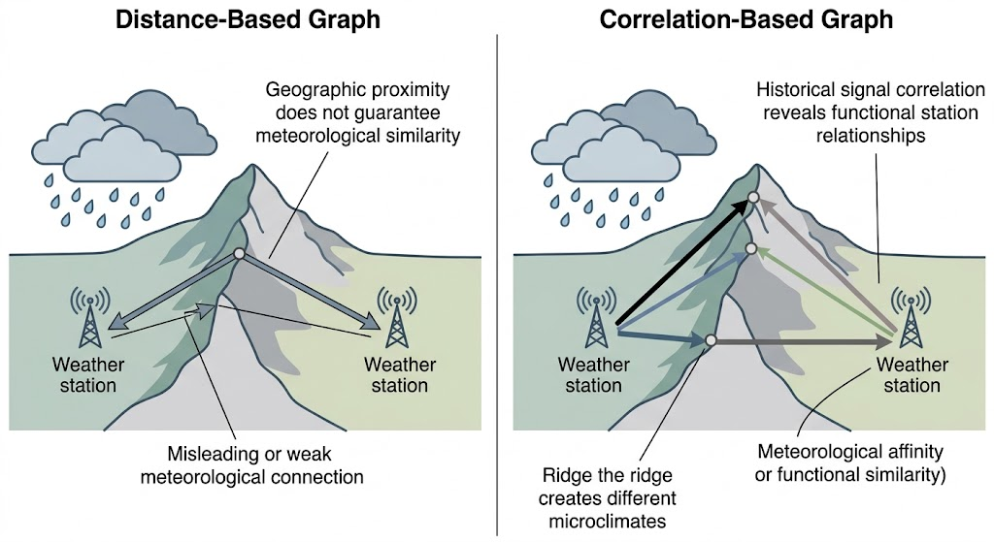
Figure 1:Conceptual diagram of distance-based versus correlation-based graph construction in complex terrain

1.2 Statement of the Problem
The central research problem is the inadequacy of distance-based spatial assumptions in graph neural network frameworks applied to weather forecasting over complex mountainous terrain, and the absence of a validated, correlation-driven alternative implemented for this setting.
Conventional approaches to spatial graph construction rely on geodesic distance Gaussian kernel weighting, where edge weights decrease as station separation increases, is standard practice in the literature [1], [8]. This is defensible in flat terrain. In complex terrain, the logic inverts. Two stations separated by a mountain ridge may be geographically close while experiencing entirely different temperature regimes and precipitation profiles. Conversely, two stations in analogous valley positions, dozens of kilometres apart on the map, may exhibit highly correlated weather histories because they are subject to the same synoptic forcing and similar orographic modifiers. A distance-based graph connects the former pair and disconnects the latter precisely backwards from what the meteorological data indicate.

When an STGCN aggregates information over a graph whose edges are defined by geographic proximity rather than atmospheric affinity, the spatial convolution can actively degrade prediction quality. Aggregating features from nearby but meteorologically dissimilar stations introduces noise into node representations, and the model must learn to suppress misleading graph-structural signals an unnecessary burden that reduces forecast accuracy and makes learned representations harder to interpret.

The research gap is specific and addressable. Despite a growing body of literature applying graph convolutional networks to spatio-temporal forecasting [8], [1], [9], no publicly documented implementation constructs a weather graph from inter-station signal correlation and integrates it with an STGCN architecture for mountainous terrain forecasting. Studies in adjacent domains traffic, air quality, and flood modelling [10], [2], [8], [6] have explored adaptive and learned graph structures, but their motivations do not translate directly to the mountainous weather problem, and their implementations have not been validated for this purpose.

This study proposes to fill that gap: how can a weather graph be constructed from historical signal correlation rather than geographic distance, and does such a graph, when embedded in an STGCN pipeline, support convergent and physically plausible multi-step prediction of temperature, humidity, and precipitation across a heterogeneous mountainous network? The study addresses this over 320 stations in Nepal and frames the validated backbone as enabling infrastructure for downstream agricultural decision support.

1.3 Research Objectives
The general objective is to design, implement, and evaluate a spatio-temporal weather forecasting framework for complex mountainous terrain in which station connectivity is defined by historical signal correlation rather than geographic distance.

The specific objectives are as follows:
- To construct a Correlation-Adaptive Weather Graph over 320 weather stations in Nepal by computing pairwise absolute Pearson correlations of historical minimum temperature time series and sparsifying the result by retaining the top 33 percent of correlation values.

- To design and implement an STGCN [1] with three ST-Conv blocks configured with temporal kernel sizes of 9, 7, and 5 and Chebyshev polynomial convolution orders of 4, 4, and 3 [11], for multi-step prediction of T2M_MIN, RH2M, and PRECTOTCORR.

- To preprocess multi-decadal daily weather records into a supervised learning format using a 43-lag sliding window and 7-step forecast horizon, producing an input tensor of dimensions N × T × C (320 × 43 × 14).

- To train and validate the STGCN using the correlation-adaptive graph, documenting convergence behavior and evaluating forecast quality on a held-out test set using MSE, MAE, and RMSE per target variable and per forecast horizon step.

- To position the validated forecasting backbone as enabling infrastructure for downstream crop advisory and agricultural decision support applications in Nepal and other complex-terrain environments.

1.4 Significance of the Study
The significance of this study operates across three dimensions: scientific, methodological, and applied.

Scientifically, the study offers a principled critique of the spatial smoothness assumption as embedded in distance-based graph construction and provides a data-driven alternative grounded in station signal statistics. The complex terrain problem is not unique to Nepal mountainous regions across South Asia, the Hindu Kush Himalaya, the Andes, and the Ethiopian Highlands face structurally similar challenges. A correlation-adaptive graph design tested and validated in Nepal provides a replicable model for these regions. The scientific literature on GNN-based weather forecasting is evolving rapidly [4], [5], [7], [12], and this study adds a terrain-aware contribution that complements global-scale and probabilistic efforts.

Methodologically, the use of absolute Pearson correlation as the basis for graph edge weights occupies a deliberate middle ground between fixed-prior approaches such as distance kernels and fully end-to-end learned approaches such as Graph WaveNet's adaptive adjacency [2]. The graph is constructed from data before training, providing a transparent and interpretable prior that reflects real inter-station meteorological relationships without being constrained by physical infrastructure or cartographic convention. Taking the absolute value rather than the signed correlation is also significant: it captures the dynamical coupling present in negatively correlated station pairs arising from temperature inversions and orographic contrasts coupling that signed correlation would suppress.

Applied, the three forecast target variables minimum temperature, relative humidity, and corrected precipitation are precisely those required by crop suitability models, irrigation scheduling algorithms, and disease risk warning systems [13]. This study does not claim to build a complete agricultural advisory system; it proposes to build and validate the forecasting backbone that such a system requires, with honest articulation of what the backbone does and does not provide.

CHAPTER 2

LITERATURE REVIEW
This chapter surveys the principal bodies of prior work establishing the theoretical and technical foundation for the proposed study. The review proceeds through four areas: the foundational GCN architecture; spatio-temporal extensions, with particular attention to STGCN; adaptive and data-driven graph construction methods; and prior work on weather forecasting in complex terrain. The chapter concludes by positioning this proposal within that landscape.

2.1 Graph Convolutional Networks
The theoretical basis of this work rests on Kipf and Welling (2017) [3], who showed that spectral graph convolutions could be efficiently approximated using a first-order Chebyshev polynomial expansion, yielding the layer-wise propagation rule:
$H^{(i+1)}$=$σ({\tilde{D}}^{-\frac{1}{2 }}\check{A}{\tilde{D}}^{-\frac{1}{2 }}H^{(l)}W^{(l)})$ [3]
Where Ã is the adjacency matrix with added self-connections, D̃ is the corresponding degree matrix, H⁽ˡ⁾ is the matrix of node activations at layer l, and W⁽ˡ⁾ is a learnable weight matrix. This formulation reduces graph convolution to a sparse matrix multiplication followed by a nonlinear activation, making it computationally tractable at scale [4]. A critical observation for this study is that the propagation rule takes the adjacency matrix as a fixed input the model does not question whether that adjacency is meaningful. In the weather station setting over complex terrain, no natural graph exists, and principled graph design becomes central rather than peripheral.

Higher-order Chebyshev polynomial convolutions [11] extend the spatial receptive field by aggregating information across K-hop neighborhoods in a single layer, with learnable coefficients per polynomial order. The STGCN architecture adopted in this proposal uses Chebyshev convolutions with orders 4, 4, and 3 across its three ST-Conv blocks [11], [1], enabling information to propagate up to four hops in the correlation graph within a single block.

2.2 Spatio-Temporal Graph Convolutional Networks
Yu, Yin, and Zhu (2018) [1] introduced STGCN as a unified architecture for structured prediction over graph-organized time series, originally demonstrated on traffic speed forecasting. The core ST-Conv block combines temporal and spatial convolution in a sandwich arrangement two gated temporal convolution layers surround a single graph convolution layer. This design allows the block to extract temporal context at each node, propagate it across the graph, then refine the spatially aggregated representation temporally. Yu et al. demonstrated that STGCN outperforms purely temporal models including Long Short-Term Memory networks [14] and purely spatial models when both spatial and temporal dependencies are present [1].

The present proposal makes two significant departures from the original traffic application. First, the graph is not inherited from physical infrastructure but is constructed from historical signal correlation the Correlation-Adaptive Weather Graph that constitutes the primary methodological contribution of this study. Second, the temporal kernel sizes are set to 9, 7, and 5 rather than the shorter kernels appropriate for traffic data, reflecting the longer temporal dependencies of meteorological systems. Synoptic-scale weather patterns typically evolve over five to ten days [1], [8], making kernel sizes in this range physically motivated.

2.3 Attention-Based and Adaptive Graph Methods
Guo et al. (2019) [10] extended the STGCN framework by introducing spatial and temporal attention mechanisms in their ASTGCN, computing a dynamic spatial attention matrix at each block to weight graph neighbors differently across time steps and prediction contexts. This addresses a recognized limitation of standard STGCN: the fixed adjacency treats spatial relationships as static, whereas in practice neighbor influence may shift with season or weather regime. The ASTGCN approach motivates a future extension of the present work combining the correlation-based prior with an attention mechanism that modulates edge weights dynamically though this remains outside the current scope.

Wu et al. (2020) [2] introduced Graph WaveNet, which learns the adjacency matrix jointly with model parameters during training via learnable node embedding matrices processed through softmax normalization. Graph WaveNet demonstrated strong performance on traffic and structured prediction benchmarks and provided an influential argument that predefined graphs especially distance-based ones may be insufficient to capture all relevant spatial dependencies [2].

The present proposal is positioned in deliberate dialogue with Graph WaveNet. Rather than learning the graph end-to-end (which reduces interpretability and requires large data volumes to avoid overfitting the graph structure), this proposal constructs the graph from absolute Pearson temperature correlation a transparent, physically grounded statistical measure. The correlation graph is a data-informed prior, not a learned parameter, and its construction from decades of historical observations provides a stable, noise-filtered representation of inter-station meteorological relationships. This design privileges interpretability and physical grounding over the flexibility of fully end-to-end learning.

2.4 Weather Forecasting in Complex Terrain
Complex terrain forecasting has challenged meteorologists for decades. Orographic effects the enhancement or suppression of precipitation and temperature gradients by airflow over terrain create sharp spatial gradients that smooth interpolation methods appropriate for flat terrain cannot resolve. The APHRODITE precipitation dataset project (Yatagai et al., 2012) [13] demonstrated that incorporating station elevation and topographic indices substantially improved gridded precipitation estimates over the Himalayas and Hindu Kush: geographic coordinates alone are insufficient when topographic relief is sharp and variable.

Machine learning approaches including random forests on reanalysis predictors, LSTM networks on station time series [14], and convolutional models on gridded fields [15] have improved on simple interpolation but have not systematically addressed the graph construction problem for station networks. They either treat each station independently, losing spatial context, or apply distance-based spatial aggregation, importing the spatial smoothness assumption they should be avoiding.

At global scale, Lam et al. (2023) [4] demonstrated exceptional forecasting skill using a graph-based neural network, but their approach is predicated on a regular global grid where distance-based adjacency is well-motivated. Price et al. (2025) [5] extended this line of work to probabilistic forecasting, while Kochkov et al. (2024) [8] demonstrated neural general circulation models capable of both weather and climate simulation. Pathak et al. (2024) [7] showed that generative diffusion modelling can emulate kilometre-scale convection-allowing models. Kazadi et al. (2024) [6] applied spatio-temporal GNNs to flood prediction in complex catchments an adjacent domain sharing the terrain-sensitivity problem with weather station forecasting. For regional station networks in complex terrain, however, the graph structure problem remains substantially underexplored, and this proposal addresses that gap directly.

2.5 Positioning of This Proposal
The table below summarises the positioning of this study relative to key prior work in the field:

Table 1: Comparison of graph-based spatio-temporal forecasting approaches relevant to this study
Approach | Graph Source | Temporal Modeling | Key Feature
GCN (Kipf & Welling, 2017) [3] | Predefined (given) | None (static) | Spectral graph convolution; Chebyshev approximation
STGCN (Yu et al., 2018) [1] | Predefined (given) | Gated causal 1D convolution | ST-Conv sandwich block; traffic forecasting
ASTGCN (Guo et al., 2019) [8] | Predefined + attention | Temporal attention | Dynamic spatial weighting; attention mechanisms
Graph WaveNet (Wu et al., 2020) [2] | Predefined + learned | Dilated causal convolution | Adaptive adjacency learned end-to-end
This Proposal | Correlation-constructed from historical T2M data | Gated causal convolution (kernels 9-7-5) | Terrain-aware data-driven graph for mountainous weather

The proposed study occupies a distinct and justifiable position. It does not accept the graph as given, as in the original GCN and STGCN works. It does not learn the graph end-to-end, as in Graph WaveNet. Instead, it constructs the graph from a principled statistical relationship specifically motivated by the failure of distance-based adjacency in complex terrain. The resulting approach is transparent, physically grounded, and reproducible for other mountainous regions attributes that distinguish it from both the fixed-prior and fully learnable alternatives, and from the large-scale global and probabilistic frameworks [4], [5], [12] that address different aspects of the weather forecasting problem.

CHAPTER 3

METHODOLOGY
This chapter describes the proposed methods in detail. The methodology is organized around five core process stages data collection, preprocessing, data splitting, model training, and forecast output classification followed by validation and verification procedures, evaluation metrics, and the software and hardware environment.
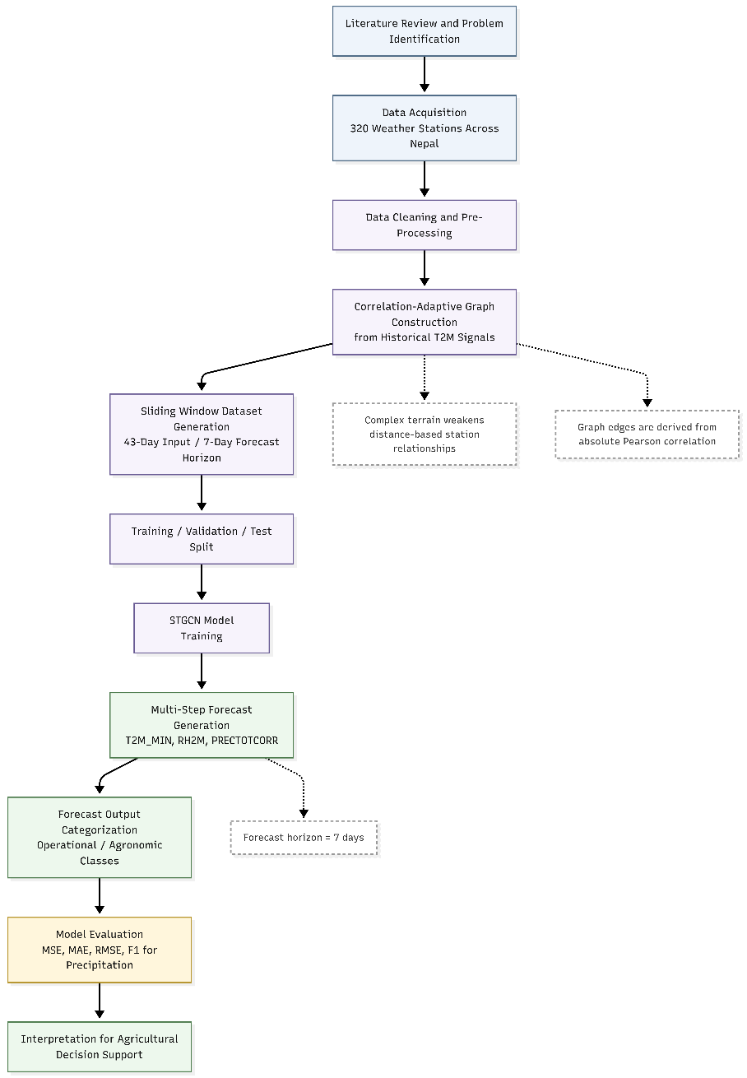

Figure 2: Schematic of the Overall Research Methodology Workflow

3.1 Process Method

3.1.1 Data Collection
The primary data source is the Weather_320_Stations_DB.csv archive, a multi-year daily meteorological record for 320 weather observation stations distributed across Nepal and surrounding regions, spanning records from 1981 through at least 2023 over four decades of daily observations. This temporal depth supports two purposes: computing stable pairwise inter-station correlations over a period long enough to capture climatological signal rather than short-term noise, and providing sufficient training samples for the supervised learning framework.
The 320 stations span Nepal's three major physiographic zones: the Terai lowlands (approximately 60–300 m), characterised by subtropical conditions with strong monsoon influence; the Middle Hills and Mahabharat range (300–3,000 m), with temperate conditions and complex orographic precipitation; and the High Himalaya (above 3,000 m), with alpine and nival conditions dominated by low temperatures, high wind exposure, and snow-dominated precipitation. This distributional diversity ensures the methodology is tested on the full range of topographic complexity that motivates the correlation-adaptive approach.
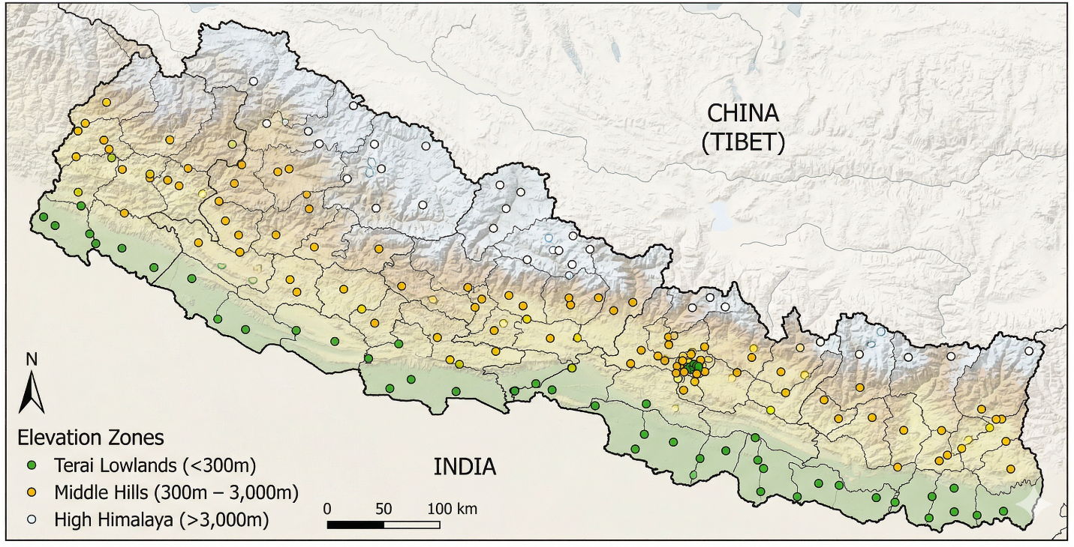
Figure 3: Spatial distribution of the 320 weather stations across Nepal's physiographic zones

Each station record contains daily values for 14 meteorological variables drawn from the NASA POWER dataset [16], organised into four physical categories as summarised in Table 2.

Table 2: Input feature variables and their physical categories used in the STGCN model
Category | Variables | Physical Significance
Thermodynamic | T2M, T2MWET, TS, T2M_MAX, T2M_MIN | Temperature regime characterization; surface energy balance; thermal stress indicators
Moisture and Precipitation | RH2M, PRECTOTCORR | Humidity-driven processes; primary water input for agriculture
Pressure | PS | Synoptic-scale context; pressure-gradient forcing
Wind (10 m and 50 m) | WS10M, WS10M_MAX, WS10M_MIN, WS50M, WS50M_MAX, WS50M_MIN | Surface and boundary-layer flow; transport and mixing

Station metadata (Stations_320_Final.csv) provides latitude, longitude, and altitude for each of the 320 nodes. These attributes are preserved for nearest-station mapping during inference but do not contribute to graph edge weights, which rely entirely on temperature signal correlation.

The three forecast target variables are not arbitrarily chosen. Minimum temperature governs frost risk, vernalization requirements, and growing-season boundaries. Relative humidity drives disease pressure modeling and evapotranspiration estimation. Corrected precipitation is the primary water input for rain-fed agriculture and drives irrigation scheduling, planting date decisions, and flood risk assessment. Together they capture the atmospheric state most relevant to agricultural decision support across Nepal's diverse topographic zones.

3.1.2 Pre-Processing
The preprocessing stage transforms raw daily records into the format required by the STGCN model through three sub-tasks: feature normalization, correlation-based graph construction, and sliding window tensor assembly.

Feature normalization applies min-max scaling or z-score standardisation to each of the 14 input variables independently across the full temporal extent of the dataset before splitting. This ensures that variables with different physical units and magnitudes are placed on a comparable numerical scale, preventing gradient imbalance during training.

The central preprocessing contribution is the construction of the Correlation-Adaptive Weather Graph, built entirely before model training and fixed throughout training and inference. The construction procedure is as follows. The preprocessed dataset is reshaped into a Date × Station matrix of daily mean temperature (T2M) values. The pairwise absolute Pearson correlation is then computed for all 320 × 320 = 102,400 station pairs, producing a symmetric correlation matrix W where w_ij represents the absolute co-variation strength between stations i and j:
$w_ij = |ρ(T_i, T_j)| = |Cov(T_i, T_j)| / (σ_i · σ_j)$ [2] [1]
Taking the absolute value rather than the signed correlation reflects a domain-specific insight about mountainous meteorology. Temperature inversions cause valley floors to cool while adjacent ridge stations warm, producing anti-correlated records between stations nonetheless tightly coupled through the same local circulation. Orographic effects cause windward stations to cool and leeward stations to warm during the same airflow event, generating anti-correlated signals at stations dynamically linked across a ridge. Foehn episodes create similar anti-correlated patterns. In all these cases, the strength of coupling not its directionality is the relevant quantity for forecasting, and the absolute correlation correctly captures this [1].

Following correlation computation, the graph is sparsified by retaining the top 33 percent of all pairwise correlation values (approximately 33,792 edges from a potential maximum of 102,400), setting lower-valued connections to zero. This filters out weak correlations that may reflect coincidental co-variation rather than genuine meteorological affinity, and substantially reduces the memory and computational requirements of graph convolution by converting the dense adjacency matrix to a sparse representation. The result is then symmetrized and augmented with self-loops to allow each node to retain its own information during convolution.

Figure 4: Correlation-Adaptive Weather Graph construction and sparsification pipeline

The final preprocessing step assembles the input tensor using a sliding window of width T_in = 43 time steps with stride 1. Each sample consists of an input tensor of dimensions N × T_in × C (320 × 43 × 14) and a target tensor of dimensions N × T_out × P (320 × 7 × 3). The choice of 43 lags provides approximately 1.5 months of meteorological context, sufficient to capture sub-seasonal patterns including monsoon development and decay, post-frontal temperature recovery, and persistent humidity regimes.

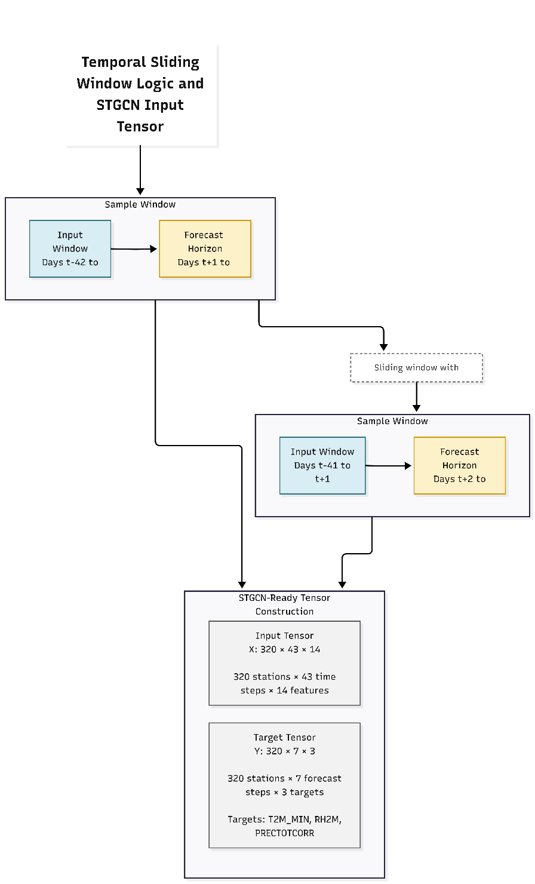
Figure 5: Temporal sliding window logic and STGCN input tensor construction

3.1.3 Data Splitting
The windowed dataset will be partitioned using two strategies compared in this study. The primary protocol is a chronological split samples from the most recent period are reserved for testing, the preceding period forms the validation set, and earlier samples form the training set (approximately 70 / 15 / 15 percent by chronological order). This reflects the operational forecasting scenario and eliminates temporal data leakage that arises when overlapping sliding windows from different periods appear on both sides of a random split boundary.

A random split at the same 85:15 train-validation proportion will be implemented as a secondary condition. While this introduces leakage risk, it remains common in the deep learning forecasting literature and provides a reference against which the chronological evaluation can be compared. The difference in validation loss between the two protocols will be reported explicitly as an estimate of how much random splitting inflates apparent accuracy.

3.1.4 Model Training
The proposed model is an STGCN [1] implemented in PyTorch with torch_geometric for graph operations. The architecture consists of three ST-Conv blocks arranged sequentially, each implementing the sandwich structure of temporal convolution → graph convolution → temporal convolution. Temporal convolutions use one-dimensional causal kernels with gating applied via a sigmoid-and-linear product. Graph convolutions use Chebyshev polynomial approximations of order K [11], set to 4 in the first two blocks and 3 in the third, enabling each block to aggregate information from up to K hops in the correlation graph.
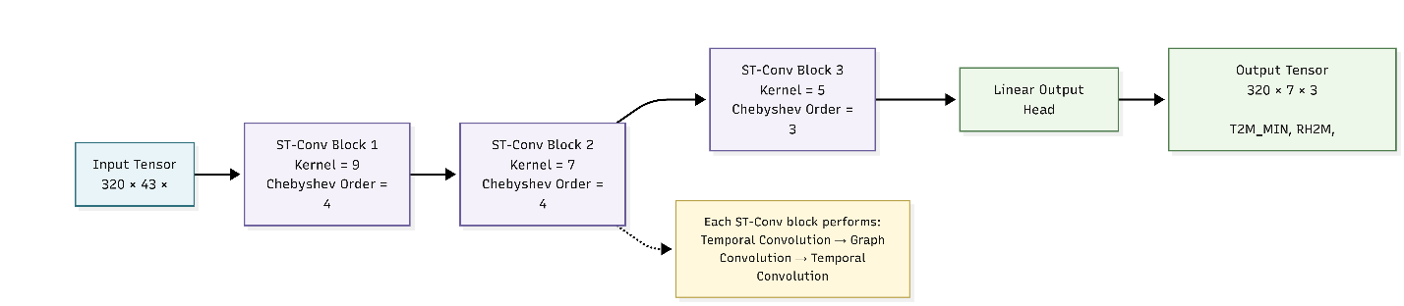
Figure 6: Architectural Overview of the Proposed Three-Block STGCN Model

The temporal kernel sizes decrease across the three blocks 9 in the first, 7 in the second, and 5 in the third reflecting progressive compression of temporal context as the representation passes through the network. The first block processes the raw 43-lag input with a large kernel to capture synoptic-scale patterns; subsequent blocks operate on shorter sequences with smaller kernels appropriate to the compressed timescales.

Table 3: Proposed STGCN model architecture and hyperparameter configuration
Parameter | Proposed Value | Justification
Optimizer | Adam | Adaptive learning rate; robust to noisy gradients in graph models
Initial Learning Rate | 0.05 | Allows fast initial descent; reduced by scheduler if needed
Batch Size | 32 | Balances memory efficiency and gradient stability
Maximum Epochs | 300 | Sufficient ceiling given early stopping
Early Stopping Patience | 15 epochs | Prevents overfitting; stops training on plateau
LR Reduction Factor | ×0.1 at patience/2 | Allows fine-grained descent near minima
Input Window (T_in) | 43 time steps (~1.5 months) | Captures sub-seasonal meteorological context
Forecast Horizon (T_out) | 7 steps (7-day horizon) | Agriculturally actionable forecast period
Temporal Kernel Sizes | 9, 7, 5 (blocks 1–3) | Matched to synoptic and weekly weather timescales
Chebyshev Orders | 4, 4, 3 (blocks 1–3) | 4-hop spatial aggregation in early blocks
Graph Sparsification Threshold | Top 33% of correlations retained | Balances noise filtering and spatial coverage

Training will proceed for a maximum of 300 epochs using the Adam optimizer (initial learning rate 0.05). A patience-based learning rate scheduler reduces the learning rate by a factor of 10 when validation loss has not improved for approximately 7–8 consecutive epochs. Early stopping halts training if no validation loss improvement is observed for 15 consecutive epochs, with the best-performing model weights saved for subsequent evaluation. The loss function is Mean Squared Error computed jointly over all predicted steps, stations, and target variables. Joint multi-target training exploits the physical coupling between the three meteorological variables minimum temperature and relative humidity are linked through the psychrometric relationship, and both are linked to precipitation through synoptic-scale dynamics providing a richer supervisory signal than training separate models.

3.1.5 Classification
Although the core task is multi-step continuous-value forecasting, the framework includes a structured output categorization stage that maps quantitative forecast values into interpretable meteorological and agronomic classes, enabling the forecast backbone to serve directly as input to downstream decision support applications.

Minimum Temperature Classification maps the continuous T2M_MIN forecast into four operational classes: Sub-zero (below 0°C, frost risk); Cold Stress (0–10°C, risk for warm-season crops); Normal Growing Range (10–25°C); and Heat Stress (above 25°C, risk for cool-season crops). Thresholds align with established crop physiology literature and regional agricultural extension advisory thresholds.

Relative Humidity Classification maps RH2M into three moisture regime classes: Low Humidity (below 50%), Moderate Humidity (50–75%), and High Humidity (above 75%). The transition to High Humidity triggers elevated disease risk warnings for fungal and bacterial crop pathogens.
Precipitation Classification maps PRECTOTCORR into four categories: No Precipitation (0 mm), Light (0–5 mm), Moderate (5–25 mm), and Heavy (above 25 mm). The distinction between dry-day and wet-day conditions is meteorologically critical and will be evaluated separately through binary skill scores alongside the continuous amount prediction.

These classification thresholds are not arbitrary binning decisions they correspond to agronomically and meteorologically meaningful boundaries that change the character of recommended agricultural actions. The classification stage preserves the full quantitative forecast for technical users while providing interpretable categorical outputs for agronomic advisory applications, allowing the framework to operate at both levels of specificity without requiring two separate models.

3.2 Validation and Verification
Model validation will proceed through a multi-layered evaluation strategy

Baseline and benchmark clarification: the direct experimental baseline for this proposal is a distance-based STGCN evaluated under the same 320-station data, targets, split, and metrics as the proposed correlation-based STGCN. Bhandari et al. (2024) is treated as a recent Nepal-specific literature benchmark, not as a one-to-one experimental baseline unless its GraphSAGE/GNN setup is reimplemented under the same protocol.

. The primary instrument is the held-out chronological test set described in Section 3.1.3, evaluated per target variable and per forecast horizon step to reveal how accuracy degrades with lead time and how different meteorological variables respond to the framework.

Convergence monitoring will use the validation loss trajectory logged at every training epoch. Training and validation loss curves will be inspected for overfitting measured as a widening gap between the two supplementing the early stopping criterion.

A baseline comparison will assess the value of the correlation-adaptive graph relative to a distance-based Gaussian kernel graph constructed from the same 320 stations and applied to the same STGCN architecture, data preparation, and evaluation protocol [1], [8]. This matched comparison isolates the effect of graph construction strategy from all other methodological choices.

Physical plausibility verification will be applied to sample forecast outputs. Forecast trajectories will be checked against climatological expectations for the corresponding season and region. A forecast that is numerically low in error but physically implausible such as sub-zero temperatures in the Terai during summer represents a qualitatively different failure mode not captured by standard error metrics.

3.3 Evaluation Metrics
The following quantitative metrics will be used to evaluate forecast performance on the held-out test set:

Table 4: Evaluation metrics for model performance assessment
Metric | Formula | Application
Mean Squared Error (MSE) | MSE = (1/n) Σ(ŷ - y)² [1], [12] | Primary training loss; differentiable; penalizes large errors heavily
Mean Absolute Error (MAE) | MAE = (1/n) Σ|ŷ - y| [1], [12] | Robust error estimate in original variable units; less sensitive to outliers
Root Mean Squared Error (RMSE) | RMSE = √MSE [1], [12] | Interpretable in original units; comparable to MAE for bias assessment

Metrics will be computed separately for each of the three target variables and for each of the seven forecast horizon steps. This disaggregated evaluation will show how forecast skill changes with lead time and whether the proposed framework performs differently across temperature, humidity, and precipitation. For precipitation, evaluation will include both continuous amount error and binary occurrence skill, since correctly identifying wet-day versus dry-day conditions is operationally important for agricultural decision support.

CHAPTER 4

EXPECTED OUTCOMES
This chapter articulates the anticipated scientific contributions, forecasting performance expectations, and practical relevance of the proposed study. These outcomes are stated prospectively and reflect reasonable expectations based on the theoretical motivations developed in Chapters 1 and 2, the methodological design in Chapter 3, and established performance benchmarks of STGCN architectures in adjacent application domains.

4.1 Scientific and Methodological Contributions
The primary scientific contribution anticipated is a validated, fully documented implementation of a Correlation-Adaptive Weather Graph embedded in an STGCN forecasting pipeline for a 320-station mountainous network. The value lies not merely in the numerical performance of the resulting model, but in demonstrating that correlation-based graph construction is a principled and practically implementable alternative to distance-based adjacency for spatio-temporal forecasting in complex terrain.

The baseline comparison experiment (Section 3.2) will provide direct quantitative evidence for or against the central claim: that a graph defined by absolute Pearson temperature correlation produces spatial structure better reflecting meteorological affinity across Nepal's diverse topographic zones than a graph defined by geodesic distance. If the correlation-adaptive graph produces lower error metrics under matched conditions, this constitutes a significant methodological result with implications for any spatio-temporal forecasting study in complex terrain. Even where the performance advantage is modest or variable, the interpretability advantage of a correlation-based prior over a purely learned or purely distance-based graph remains a meaningful contribution to the literature [2], [12].

The study also contributes a systematic analysis of STGCN temporal dynamics applied to meteorological data at daily resolution. The decreasing kernel schedule of 9, 7, and 5 time steps across the three ST-Conv blocks is physically motivated but has not been systematically evaluated for daily weather forecasting. Per-horizon error analysis will provide evidence about whether this temporal configuration is well-matched to the target domain.

4.2 Forecasting Performance Expectations
Based on convergence behavior reported for similar STGCN configurations in traffic and environmental domains [1], [8], and on recent benchmarks for data-driven weather models [11b], [5], [12], the proposed model is expected to demonstrate clear convergence over the training period. Validation loss is anticipated to decrease by approximately 90–96 percent over 150–200 epochs before early stopping.

For T2M_MIN, the model is expected to achieve RMSE values in the range of 1–3°C across the seven-day horizon, with forecast skill degrading with lead time as is characteristic of all weather forecasting systems, including state-of-the-art global data-driven models [4], [5]. Relative humidity forecasting is expected to perform with moderate skill given the high temporal autocorrelation of RH2M signals, though variability across elevation gradients may limit accuracy at high-altitude stations. Precipitation forecasting is inherently more challenging given its intermittent, spatially heterogeneous character; the model is expected to perform better on occurrence prediction than on precise amount estimation [15].

Seven-step forecast outputs are expected to produce physically plausible trajectories temperature trends consistent with seasonal forcing, humidity within physiologically reasonable bounds, and precipitation intermittency matching climatological expectations. These physical plausibility characteristics will be documented alongside quantitative error metrics as part of the results presentation.

4.3 Application Relevance and Future Integration
The proposed framework is designed as enabling infrastructure for agricultural decision support systems in Nepal [13]. A validated seven-day forecast at 320 stations across Nepal's physiographic zones provides spatial and temporal resolution appropriate for smallholder farming advisory services. The study proposes to build, validate, and document the forecasting backbone graph construction code, trained model weights, nearest-station inference interface, and forecast output classification scheme as a reproducible and integrable pipeline.
The forecast output categorisation scheme (Section 3.1.5) bridges the gap between quantitative meteorological outputs and operational agronomic decisions. By mapping T2M_MIN into frost risk categories, RH2M into disease pressure moisture classes, and PRECTOTCORR into irrigation-relevant precipitation categories, the system provides outputs immediately interpretable by agricultural extension practitioners without requiring meteorological expertise.

Beyond Nepal, the methodology is expected to generalise to other complex-terrain environments where distance-based graph construction is similarly problematic [13], [4]. The Correlation-Adaptive Weather Graph construction pipeline requires only a historical temperature archive of sufficient length and a station coordinate file it does not depend on Nepal-specific features. Researchers working in the Hindu Kush Himalaya, the Andes, the Ethiopian Highlands, or other mountainous agricultural regions should find the approach directly adaptable, particularly as global-scale data-driven weather models [4], [5], [7] become increasingly capable and regionally downscaled data products become more accessible.

CHAPTER 5

THESIS SCHEDULE
The following schedule outlines the proposed timeline for completing all research activities from initial literature review through final thesis submission. The schedule is designed for a two-year Master's programme and assumes full-time research engagement, organised in monthly blocks with major milestones at the end of each phase.
Table 5: Proposed thesis research schedule
Month | Activity
1-2 | Data preprocessing and graph construction
3 | Baseline implementation
4-5 | Model training and tuning
6 | Comparative evaluation
7 | Thesis writing and revision

REFERENCES

[1] | B. Yu, H. Yin and Z. Zhu, "Spatio-temporal graph convolutional networks: A deep learning framework for traffic forecasting," in Proceedings of the 27th International Joint Conference on Artificial Intelligence, 2018.
[2] | Z. Wu, S. Pan, F. Chen, G. Long, C. Zhang and P. S. Yu, "Connecting the dots: Multivariate time series forecasting with graph neural networks," in Proceedings of the 26th ACM SIGKDD International Conference on Knowledge Discovery and Data Mining, 2020.
[3] | T. N. Kipf and M. Welling, "Semi-supervised classification with graph convolutional networks," in International Conference on Learning Representations, 2017.
[4] | R. Lam, A. Sanchez-Gonzalez, M. Willson, P. Wirnsberger, M. Fortunato, F. Alet and P. Battaglia, "Learning skillful medium-range global weather forecasting," Science, vol. 382, no. 6677, pp. 1416-1421, 2023.
[5] | I. Price, A. Sanchez-Gonzalez, F. Alet, T. R. Andersson, A. El-Kadi and D. Masters, "Probabilistic weather forecasting with machine learning," Nature, vol. 637, pp. 84-90, 2025.
[6] | A. Kazadi, J. Doss-Gollin, A. Sebastian and A. Silva, "FloodGNN-GRU: a spatio-temporal graph neural network for flood prediction," Environmental Data Science, vol. 3, p. e21, 2024.
[7] | J. Pathak, Y. Cohen, P. Garg, P. Harrington, N. Brenowitz and D. Durran, "Kilometer-Scale Convection Allowing Model Emulation using Generative Diffusion Modeling," arXiv:2408.10958, 2024.
[8] | L. Zhao, Y. Song, C. Zhang, Y. Liu, P. Wang, T. Lin, M. Deng and H. Li, "T-GCN: A temporal graph convolutional network for traffic prediction," IEEE Transactions on Intelligent Transportation Systems, vol. 21, no. 9, pp. 3848-3858, 2020.
[9] | S. Rasp, S. Hoyer, A. Merose, I. Langmore, P. Battaglia and T. Russell, "WeatherBench 2: A benchmark for the next generation of data-driven global weather models," Journal of Advances in Modeling Earth Systems, vol. 16, p. e2023MS004019, 2024.
[10] | Y. Lin, N. Feng, C. Song and H. Wan, "Attention based spatial-temporal graph convolutional networks for traffic flow forecasting," in Proceedings of the AAAI Conference on Artificial Intelligence, 2019.
[11] | M. Defferrard, X. Bresson and P. Vandergheynst, "Convolutional neural networks on graphs with fast localized spectral filtering," in Advances in Neural Information Processing Systems, 2016.
[12] | X. Sun, J. Li, Z. Zhao, G. Jing, B. Chen, J. Hu, F. Wang and Y. Zhang, "Utility of Graph Neural Networks in Short-to Medium-Range Weather Forecasting," Computers, Materials and Continua, vol. 84, no. 2, pp. 2121-2149, 2025.
[13] | A. Yatagai, K. Kamiguchi, O. Arakawa, A. Hamada, N. Yasutomi and A. Kitoh, "APHRODITE: Constructing a long-term daily gridded precipitation dataset for Asia based on a dense network of rain gauges," Bulletin of the American Meteorological Society, vol. 93, no. 9, pp. 1401-1415, 2012.
[14] | S. Hochreiter and J. Schmidhuber, "Long short-term memory," Neural Computation, vol. 9, no. 8, pp. 1735-1780, 1997.
[15] | X. Shi, Z. Chen, H. Wang, D.-Y. Yeung, W.-K. Wong and W.-C. Woo, "Convolutional LSTM network: A machine learning approach for precipitation nowcasting," in Advances in Neural Information Processing Systems, 2015.
[16] | NASA POWER Project, "NASA POWER," April 2023. [Online]. Available: https://power.larc.nasa.gov/. [Accessed 2026].
[17] | D. Kochkov, J. Yuval, I. Langmore, P. Norgaard, J. Smith and G. Mooers, "Neural general circulation models for weather and climate," Nature, vol. 632, pp. 1060-1066, 2024.

